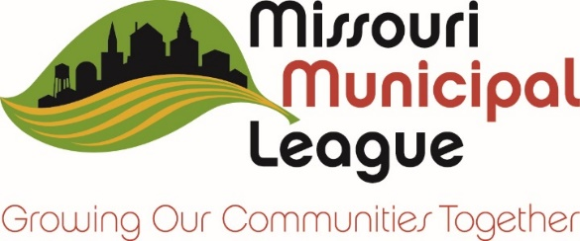
City Logo Here

NEWS RELEASE
(Date) _______________________
FOR IMMEDIATE RELEASE
For more information, contact ___________________________________________

[Title]_______ Designated a Certified Municipal Official in
the Municipal Governance Institute
JEFFERSON CITY - [Title] _______ of [name of Municipality] has earned the prestigious designation of Certified Municipal Official from the Missouri Municipal League’s Municipal Governance Institute.
The Municipal Governance Institute was created under the direction of the Missouri Municipal League’s board of directors, to provide a training program focused on the important areas municipal officials and professional staff need for success. In order to achieve this high honor, a municipal official must complete 16 credit hours of training conducted or endorsed by the Municipal Governance Institute.
Through [his/her] attendance at statewide and regional MGI sanctioned educational events, [Title _________________], has received training in subjects such as council meeting procedures, parliamentary procedures, the Missouri Open Meetings and Records Law, conflicts of interest, the State Ethics Law, duties of the mayor and council, tort liability, purchasing and bidding requirements, municipal revenues sources, personnel law, emergency management and budgeting.
“All MGI graduates spend many hours over several years attending workshops and lectures on the finer points of municipal government,” said Richard Sheets, Executive Director of the Missouri Municipal League. “Earning the CMO designation is a significant achievement, and I commend our graduates for their dedication and motivation to become better informed and more effective municipal officials.”
The Missouri Municipal League was organized in 1934 and now serves nearly 650 cities as the recognized voice for municipalities in Missouri. This voluntary membership program brings officials of cities and towns together in fellowship of public service that strengthens and guides local government in a progressive, responsible fashion. The primary purpose of the League is to promote understanding of municipal government and administration in Missouri and thereby advance the welfare of the people of this state.
###

